GULF ASHLEY MOTOR LIMITED

CIN: U34102TN2004PLC052489

Registered Office: No.1, Sardar Patel Road, Guindy, Chennai 600 032
(Landmark: Near ITC Grand Chola)
(Route Map: Enclosed)
Tel : +91 44 2220 6000 Fax : +91 44 2220 6001
e-mail: info@gamltrucks.com; website www.gamltrucks.com
______________________________________________________________________________

NOTICE TO SHAREHOLDERS

Notice is hereby given that an Extra-Ordinary General Meeting of the Members of Gulf Ashley Motor Limited will be held on Saturday, November 7, 2015 at 10.45 a.m. at shorter notice at 1, Sardar Patel Road, Guindy, Chennai 600 032 to transact the following business:

- To consider and if though fit, to pass with or without modification(s), the following as an Ordinary Resolution:

RESOLVED that pursuant to Section 61 and its related and applicable provisions of the Companies Act, 2013 and Rules made thereunder, the Authorised Capital of the Company be increased from Rs. 20,00,00,000 (Rupees Twenty Crore only) divided into 20,00,000 equity shares of Rs.100/- each to Rs.40,00,00,000 (Rupees Forty Crore only) divided into 40,00,000 equity shares of Rs. 100/- each , by creation of 20,00,000 equity shares of Rs.100/- each.
RESOLVED FURTHER that the Clause V of Memorandum of Association of the Company be and is hereby substituted as follows:

- The Authorised Share Capital of the Company is Rs. 40,00,00,000 (Rupees Forty Crore only) divided into 40,00,000 (Forty Lakhs only) equity shares of Rupees 100/- (Rupees Hundred only) each with power to increase and reduce the Capital of the Company and to divide the shares in the Capital for the time being into several classes and to attach thereto respectively such preferential rights, privileges or conditions as may be determined by or in accordance with the regulations of the Company and to vary, modify or abrogate any such rights, privileges or conditions in such manner as may for the time being be provided by the regulations of the Company and to consolidate or subdivide the shares and issue shares of higher or lower denominations as permitted by the Act.

- To consider and if though fit, to pass with or without modification(s), the following as a Special Resolution:

RESOLVED THAT the Clause 3 of Articles of Association of the Company be and is hereby substituted as follows:

- The Authorised Share Capital of the Company is Rs. 40,00,00,000 (Rupees Forty Crore only) divided into 40,00,000 (Forty Lakh only) equity shares of Rupees 100/- (Rupees Hundred only) each with power to subdivide, consolidate , and increase or decrease and with power from time to time to issue any shares of the original capital with and subject to any preferential, deferred, qualified or special rights, privileges or conditions as may be, thought fit, and upon subdivision of shares to apportion the right to participate in profits, in any manner as between the shares resulting from subdivision.

Registered Office: By the Order of the Board
No.1, Sardar Patel Road,
Guindy, Chennai- 600 032
K Priya
Chennai Company Secretary
November 5, 2015

NOTES:

- A MEMBER ENTITLED TO ATTEND AND VOTE AT THIS GENERAL MEETING IS ENTITLED TO APPOINT ONE OR MORE PROXIES TO ATTEND AND VOTE INSTEAD OF HIMSELF/HERSELF AND THE PROXY NEED NOT BE A MEMBER OF THE COMPANY. A person can act as proxy on behalf of members not exceeding fifty (50) and holding in the aggregate not more than ten percent of the total share capital of the Company carrying voting rights.

THE PROXY FORM SHOULD BE LODGED WITH THE COMPANY AT LEAST 48 HOURS BEFORE THE SCHEDULED COMMENCEMENT OF THE MEETING.

- The Explanatory Statement pursuant to Section 102 of the Companies Act, 2013, in respect of details relating to Special Business is furnished below.

Explanatory Statement pursuant to Section 102 of the Companies Act, 2013

Item No 1 and 2

The Members are requested to note that in order to meet the business requirements, the authorised capital of the Company has to be enhanced from Rs. 20 crore to Rs. 40 crore by issue of 40,00,000 equity shares of Rs. 100 each to the existing shareholders of the Company.

As Per section 61 of Companies Act, 2013, the alteration of the Memorandum of Association and Articles of Association of the Company requires the approval of shareholders. The Board now seeks the approval of shareholders for the same.

The above proposal is in the interests of the Company.

None of the Directors and Key Managerial Personnel of the Company and their relatives is concerned or interested, financial or otherwise, in this resolution.

Registered Office: By the Order of the Board
No.1, Sardar Patel Road,
Guindy, Chennai- 600 032
K Priya
Company Secretary
Chennai
November 5, 2015

Route Map

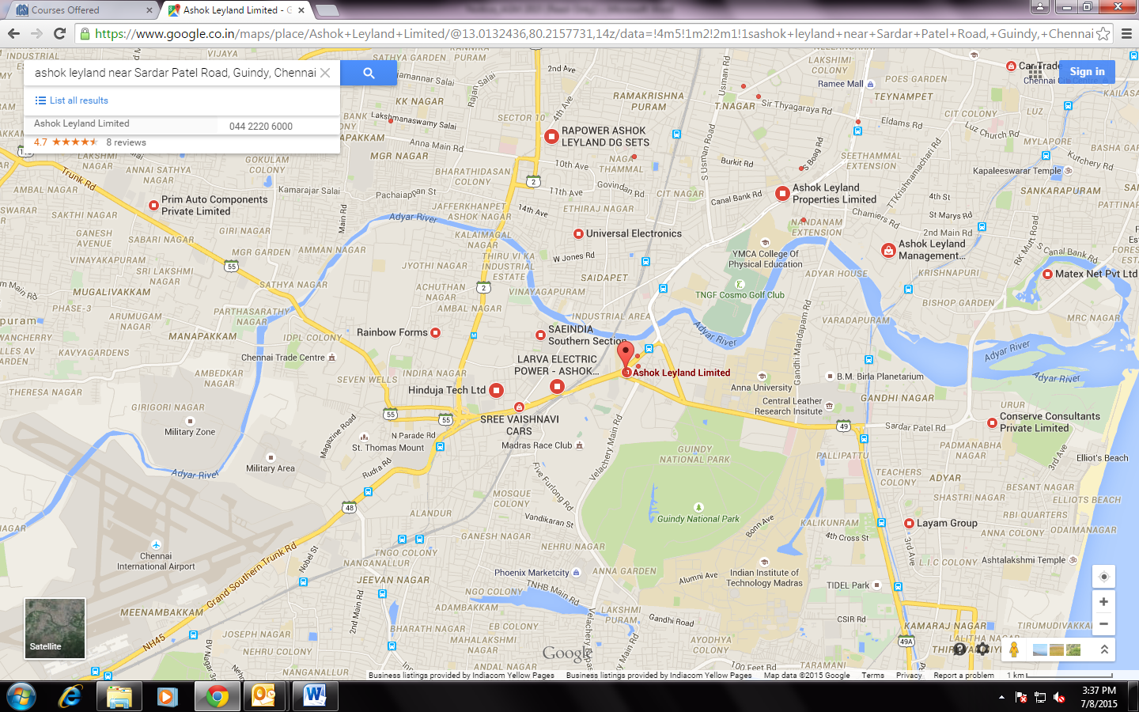

GULF ASHLEY MOTOR LIMITED
CIN-U34102TN2004PLC052489, Registered Office: No.1, Sardar Patel Road, Guindy, Chennai- 600 032
Tel:+91 44-22206000, Fax: +91 44-2220 6001, E-mail: info@gaml.trucks.com , Website: www.gamltrucks.com

EXTRA-ORDINARY GENERAL MEETING
PLEASE COMPLETE THE SLIP AND HAND IT OVER AT THE ENTRANCE OF THE MEETING HALL

ADMISSION SLIP
NAME & ADDRESS OF THE MEMBER

I hereby record my presence at the EXTRA-ORDINARY GENERAL MEETING of the Company, at No.1, Sardar Patel Road, Guindy, Chennai- 600 032 at 10.45 a.m. on Saturday, November 7, 2015.
Name of the shareholder / proxy * | Signature of the shareholder / proxy *
*Strikeout whichever is not applicable
……………………………………………………………………………………………………………………………………………………………………
GULF ASHLEY MOTOR LIMITED
CIN-U34102TN2004PLC052489, Registered Office: No.1, Sardar Patel Road, Guindy, Chennai- 600 032
Tel:+91 44- 22206000, Fax: +91 44-2220 6001, E-mail: info@gaml.trucks.com , Website: www.gamltrucks.com

EXTRA-ORDINARY GENERAL MEETING

PROXY FORM (MGT – 11)
Folio No. Depository A/c No
I / We being the member(s) of …………., shares of the above named company hereby appoint
1.Name | 2.Name | 3.Name
Address | Address | Address
e-mail id | e-mail id | e-mail id
Signature ………………………………………. Or failing him/her | Signature ……………………………………….  Or failing him/her | Signature …………………………….  Or failing him/her
as my / our proxy to attend and vote (on a poll) for me/us and on my/our behalf at the Extra-Ordinary General Meeting of the Company to be held at No.1, Sardar Patel Road, Guindy, Chennai- 600 032 at 10.45 a.m. on Saturday, November 7, 2015 and at any adjournment thereof in respect of such resolutions, as are indicated overleaf.
Revenue Stamp
Signed this _________________________ day of __________________________ 2015

Name: ________________________________________________________ Signature: _____________________________________________________
Signature of the Proxy
Registered Address: _______________________________________________________

Note: This form of proxy in order to be effective should be duly completed and deposited at the Registered Office of the Company, not less than 48 hours before the commencement of the Meeting. The proxy need not be a Member of the Company.

Please see overleaf

…………………………………………………………………………………………………………………………………………………………………………

S.No |  | Resolutions :
Special Business:
1 | To consider and if though fit, to pass with or without modification(s), the following as a Special Resolution
(a) | Enhancement of Authorised capital from Rs 20 Crore to Rs 40 Crore.

